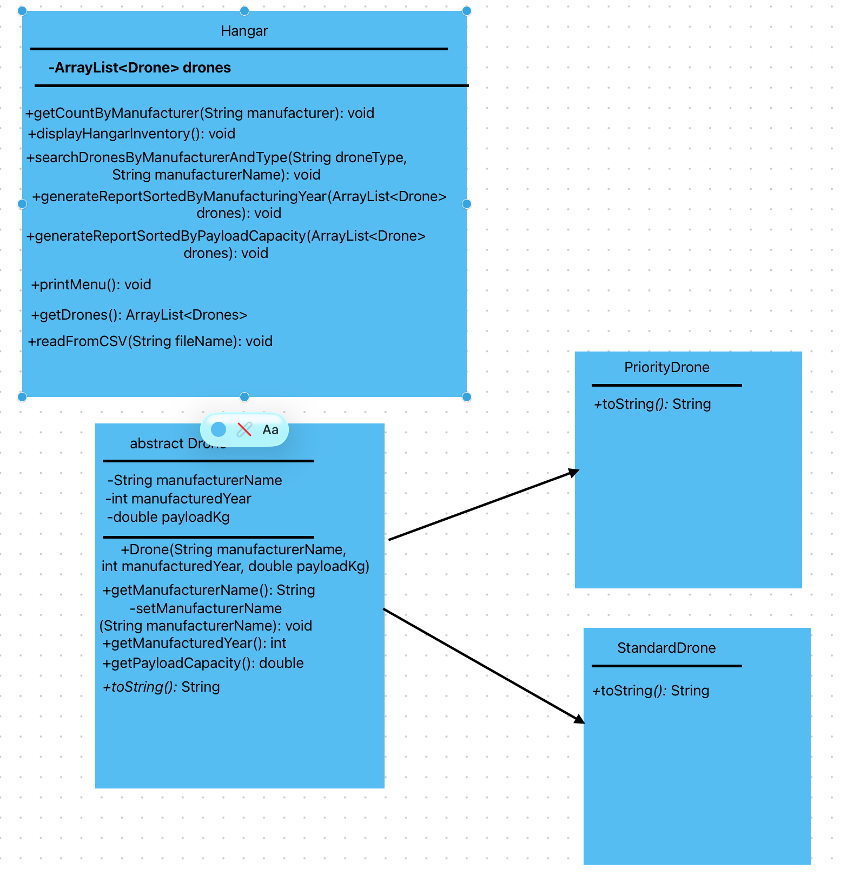

Purpose | Input / Setup | Expected Result
Verify valid drone records are loaded from a correctly formatted CSV file | CSV file contains: S,DJI,2021,12.5 and P,Skydio,2024,18.0 | Two drone objects are added to the hangar inventory
Verify a CSV line with too few fields is skipped | CSV line: P,2024,18.0 | Line is skipped and an error message is displayed
Verify a CSV line with an invalid drone type is skipped | CSV line: X,Parrot,2019,5.2 | Line is skipped and an error message is displayed
Verify a CSV line with a non-numeric year or payload is skipped | CSV line: S,DJI,2021,1O | Line is skipped and an error message is displayed
Verify a CSV line with a negative payload is skipped | CSV line: S,DJI,2021,-4.0 | Line is skipped and an error message is displayed
Verify a CSV line with a missing manufacturer is skipped | CSV line: S,,2021,12.5 | Line is skipped and an error message is displayed
Verify file-not-found handling works correctly | Enter a file name that does not exist | No drones are loaded and a file-not-found message is displayed
Verify counting works when a manufacturer has multiple drones | Inventory contains 2 DJI drones and 1 Autel drone; input manufacturer: DJI | Program reports a total count of 2
Verify counting works when a manufacturer has one drone | Inventory contains 1 Skydio drone; input manufacturer: Skydio | Program reports a total count of 1
Verify counting returns zero when the manufacturer is not present | Inventory contains DJI and Autel drones; input manufacturer: Parrot | Program reports a total count of 0
Verify manufacturer counting is case-insensitive | Inventory contains manufacturer DJI; input manufacturer: dji | Program reports the correct count for DJI
Verify payload sorting orders drones from lowest to highest | Inventory payloads: 12.5, 18.0, 5.2, 9.0 | Sorted report displays payload order: 5.2, 9.0, 12.5, 18.0
Verify payload sorting does not change the original inventory order | Inventory is loaded in one order, then payload sort is run | Sorted report is correct, but original hangar inventory remains unchanged
Verify payload sorting handles an empty inventory without crashing | Inventory is empty | Sort report runs without errors and displays no drone records
Verify search finds matching priority drones for a manufacturer | Inventory contains a Priority Drone from Autel; input manufacturer: Autel, type: Priority | Matching priority drone is displayed
Verify search finds matching standard drones for a manufacturer | Inventory contains a Standard Drone from DJI; input manufacturer: DJI, type: Standard | Matching standard drone is displayed
Verify search supports abbreviated type input | Inventory contains a Priority Drone from Skydio; input manufacturer: Skydio, type: P | Matching priority drone is displayed
Verify search by manufacturer is case-insensitive | Inventory contains manufacturer Autel; input manufacturer: autel, type: Priority | Matching drone is displayed
Verify search reports no matches when none exist | Inventory contains only DJI drones; input manufacturer: Autel, type: Priority | Program displays a no-results message
Verify search rejects an invalid drone type | Input manufacturer: DJI, type: Express | Program displays an invalid drone type message

